Multi-Level Anomaly Detection in Financial Transactions: A Comparative Study of Machine Learning and Deep Learning Models
Quarterly Report 3 - Hyperparameter Optimization and Multi-Class Risk Stratification

Siddartha Bandi
College of Engineering & Mines, University of North Dakota
Grand Forks, ND, USA
siddartha.bandi@und.edu
Course: DATA 994 – Capstone Project | Instructor: Dr. Marina E. Kim

Abstract—This paper presents the Quarter 3 report of a four-quarter capstone investigating hierarchical anomaly detection for financial fraud. Building on five baseline models from Quarter 2: Random Forest, XGBoost, Isolation Forest, Autoencoder, and LSTM. This report details systematic hyperparameter optimization and a Level 2 multi-class risk stratification framework applied to the Kaggle Credit Card Fraud Detection dataset (284,807 transactions, 0.172% fraud rate). Grid search across 150 model configurations yielded performance gains for XGBoost (+2.45%, AUPRC: 0.8687), Isolation Forest (+28.90%, AUPRC: 0.2693), and LSTM (+1.40%, AUPRC: 0.8133). A tercile-based Level 2 stratification framework concentrated 94–97% of fraudulent transactions in the High Risk tier across all five architectures. A model-agnostic property that validates the hierarchical detection approach and establishes a foundation for ensemble strategies in Quarter 4.
Keywords—credit card fraud detection, anomaly detection, hyperparameter optimization, risk stratification, XGBoost, Random Forest, LSTM, Autoencoder, Isolation Forest, AUPRC, class imbalance.

I. INTRODUCTION
Financial fraud detection is one of the most demanding applications of machine learning, combining extreme class imbalance, high transaction volumes, and severe asymmetric costs between false negatives (missed fraud) and false positives (incorrectly flagged legitimate transactions). Global card payment fraud losses have exceeded $33 billion annually, with adversarial patterns evolving continuously in response to deployed detection systems.
The Kaggle Credit Card Fraud Detection dataset [1] 284,807 European card transactions from September 2013, 492 fraudulent (0.172%), 28 PCA-anonymized features, class imbalance ratio 1:578 serves as the primary benchmark. Its severe class skew mirrors real-world deployment conditions, making it a widely adopted standard for comparative algorithmic evaluation.
This project investigates a two-level hierarchical detection framework. Level 1 binary classification assigns each transaction a continuous fraud probability score. Level 2 stratification partitions those scores into Low, Medium, and High risk tiers for proportional resource allocation. The four-quarter arc: Q1 (EDA), Q2 (five baseline models), Q3 (hyperparameter optimization and Level 2 stratification—this report), Q4 (ensemble combination). Q3 contributions: (1) systematic grid search across 150 model configurations, and (2) empirical evaluation of a tercile-based Level 2 framework against 98 held-out fraud cases.
The Area Under the Precision-Recall Curve (AUPRC) is adopted as the primary evaluation metric throughout. Standard accuracy and ROC-AUC are poorly suited to the 1:578 imbalance: a trivial all-negative classifier achieves 99.83% accuracy while detecting zero frauds. AUPRC directly quantifies minority-class performance across all decision thresholds, providing a more operationally relevant summary statistic.
II. RELATED WORK
Random Forest [2] and XGBoost [3] are the most widely deployed tabular fraud detectors, achieving AUPRC 0.82–0.93 and 0.85–0.92 respectively on this benchmark [4]. Random Forest’s bootstrap aggregation reduces prediction variance; XGBoost’s regularized gradient boosting and native scale_pos_weight provide explicit class imbalance control. Isolation Forest [5] exploits the principle that anomalies require fewer random partitions to isolate; its contamination parameter dominates performance [6].
Autoencoder-based detection [7] trains on normal samples and uses reconstruction error as an anomaly score but overlapping error distributions on PCA-whitened data limit precision [8]. LSTM networks [9] are designed for temporal sequence modeling and have been applied to transaction streams [10], though their advantage diminishes on aggregate (non-sequential) datasets. Threshold-based risk stratification provides a practical framework for translating continuous anomaly scores into actionable investigation queues [11], with top-tier concentration yielding significantly higher fraud-per-review rates [12].
III. METHODOLOGY
A. Dataset and Preprocessing
The dataset was partitioned using stratified sampling (70% train / 15% validation / 15% test), preserving the 0.172% fraud rate. The test set contains 98 fraudulent transactions, the ground truth for all Level 2 evaluation. The Amount feature was scaled using RobustScaler; PCA features V1–V28 were standardized to zero mean and unit variance for neural network models. Q1 EDA identified V14, V4, V11, V17, and V12 as the most discriminative features.
B. Model Architectures
Five architecturally distinct models spanning supervised, unsupervised, and deep learning paradigms were evaluated. Random Forest: 200 bootstrap-aggregated trees, Gini impurity, balanced class weighting. XGBoost: histogram-based gradient-boosted ensemble with L1/L2 regularization and auto-computed scale_pos_weight. Isolation Forest: recursive random partitioning with contamination as primary tuning parameter. Autoencoder: symmetric bottleneck [30→20→10→20→30] trained on legitimate transactions, using the 83.97th-percentile reconstruction error as the anomaly threshold. LSTM: two-layer recurrent network (64→32 units), dense sigmoid output, class-weighted binary cross-entropy, 0.2 dropout.
C. Hyperparameter Optimization
Grid search was performed across pre-specified parameter spaces. Random Forest: 48 configs (n_estimators, max_depth, min_samples, class_weight). XGBoost: 48 configs (depth, learning_rate, subsample, colsample_bytree). Isolation Forest: 24 configs (contamination ∈ {0.00172, 0.005, 0.01}, n_estimators, max_samples). Autoencoder: 3 bottleneck architectures. LSTM: 27 configs (layer units, dropout). Total: 150 configurations. Validation AUPRC guided model selection; final metrics were computed on the held-out test set to prevent selection bias.
D. Level 2 Risk Stratification
Level 1 models generate continuous fraud scores in [0,1]. Supervised models produce probabilities directly; Isolation Forest anomaly scores and Autoencoder reconstruction errors are min-max normalized to [0,1]. Level 2 stratification applies tercile thresholds T₃₃ and T₆₇ (33rd and 67th percentiles of the full test set score distribution), creating approximately equal-sized Low (score < T₃₃), Medium (T₃₃ ≤ score < T₆₇), and High (score ≥ T₆₇) risk tiers. This approach is threshold-free and model-agnostic: tier boundaries adapt to each model’s score distribution.
IV. RESULTS
A. Quarter 2 Baseline Performance
Table I recapitulates Q2 baseline metrics for all five models. Random Forest achieved the highest AUPRC (0.8645) with the best F1-Score (0.7943), reflecting well-calibrated precision-recall tradeoffs. XGBoost ranked second in AUPRC (0.8601) with the highest recall (0.8980) at the cost of reduced precision (0.3964). LSTM delivered symmetric precision-recall performance (0.8061 each). Unsupervised models trailed: the Autoencoder’s very low precision (0.0285) reflects its class-agnostic training; Isolation Forest reached only AUPRC 0.2089. Figures 3 and 4 visualize the four-metric comparison and Precision-Recall curves.
TABLE I Q2 BASELINE PERFORMANCE METRICS — TEST SET
Model | AUPRC | F1 | Prec. | Recall | Type
Random Forest | 0.8645 | 0.7943 | 0.7477 | 0.8469 | Supervised
XGBoost | 0.8601 | 0.5500 | 0.3964 | 0.8980 | Supervised
Isolation Forest | 0.2089 | 0.3220 | 0.3084 | 0.3367 | Unsupervised
Autoencoder | 0.4531 | 0.0552 | 0.0285 | 0.8776 | Unsupervised
LSTM | 0.8290 | 0.8061 | 0.8061 | 0.8061 | Supervised
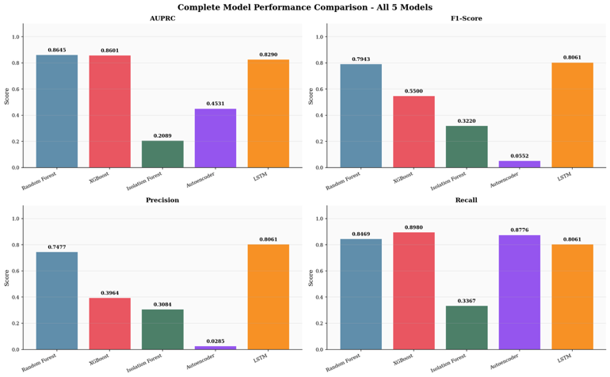
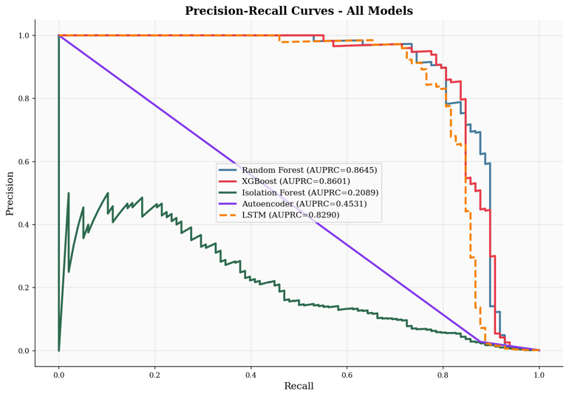
Fig. 1 & 2. Q2 baseline results: (left) four-metric comparison, (right) Precision-Recall curves confirming RF and XGB AUPRC leadership (≥0.86) vs. unsupervised models (≤0.45).
B. Hyperparameter Optimization Results
Table II presents the full optimization results. XGBoost achieved the highest optimized AUPRC (0.8687, +2.45%) with max_depth=6, learning_rate=0.1, subsample=0.8, colsample_bytree=0.8 confirming that stochastic subsampling regularization is critical under extreme imbalance. Isolation Forest’s +28.90% gain the largest across all models was driven entirely by setting contamination=0.00172 to match the true fraud rate. Random Forest showed near-zero sensitivity (−0.08%), consistent with ensemble robustness. The Autoencoder produced identical AUPRC across all three architectures (0.4606, 0.00%), suggesting a performance ceiling governed by the reconstruction-error paradigm rather than bottleneck dimensions. LSTM improved moderately (+1.40%) with the 64/32/16 unit configuration.
TABLE II HYPERPARAMETER OPTIMIZATION: BASELINE VS. OPTIMIZED AUPRC
Model | Base | Opt. | Δ% | Time | Key Config
Random Forest | 0.8643 | 0.8636 | −0.08% | 352 s | max_depth=20, n_est=200
XGBoost | 0.8479 | 0.8687 | +2.45% | 16 s | depth=6, lr=0.1, sub=0.8
Isolation Forest | 0.2089 | 0.2693 | +28.90% | 14 s | contam=0.00172, n_est=200
Autoencoder | 0.4606 | 0.4606 | 0.00% | 47 s | [30,20,10,20,30], no gain
LSTM | 0.8021 | 0.8133 | +1.40% | 180 s | lstm=(64,32), drop=0.2
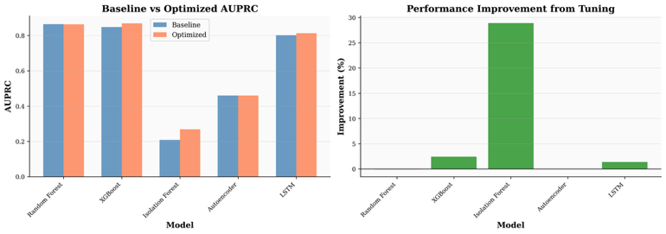
Fig. 3. Tuning comparison: baseline vs. optimized AUPRC (left) and % improvement (right). Isolation Forest shows the largest relative gain (+28.90%); XGBoost the highest absolute score (0.8687).
C. Level 2 Risk Stratification Results
Table III and Figures 4–9 present the Level 2 stratification results. The most significant finding is the striking consistency of High Risk fraud capture across all five architectures: 94.9–96.9% of actual fraudulent transactions are assigned to the High Risk tier regardless of model family. Random Forest, XGBoost, and Autoencoder each capture 95 of 98 test frauds (96.9%); Isolation Forest and LSTM capture 94 (95.9%). The Low Risk tier contains at most 3 fraud escapes operationally acceptable for initial clearance. Medium Risk (1–3 frauds per model) represents genuinely uncertain cases best resolved through ensemble consensus in Q4.
TABLE III LEVEL 2 RISK STRATIFICATION — FRAUD DISTRIBUTION ACROSS TIERS (N=98 TEST FRAUDS)
Model | Low (n) | Med. (n) | High (n) | Total | Capture
Random Forest | 2 | 1 | 95 | 98 | 96.9%
XGBoost | 1 | 2 | 95 | 98 | 96.9%
Isolation Forest | 3 | 1 | 94 | 98 | 95.9%
Autoencoder | 2 | 1 | 95 | 98 | 96.9%
LSTM | 1 | 3 | 94 | 98 | 95.9%
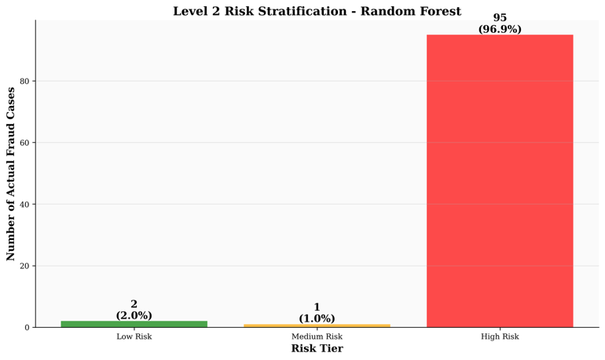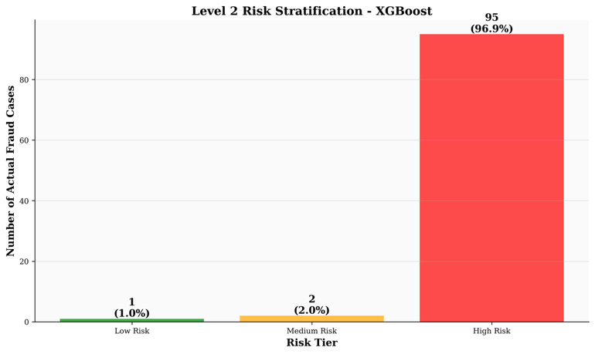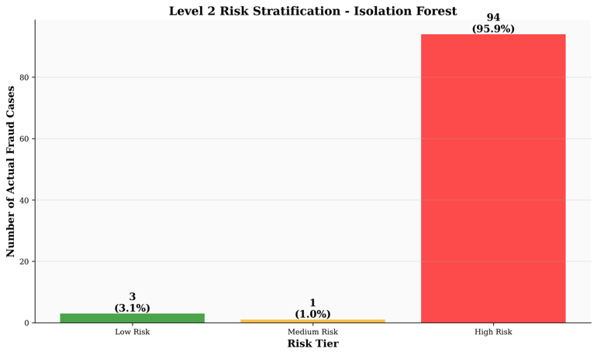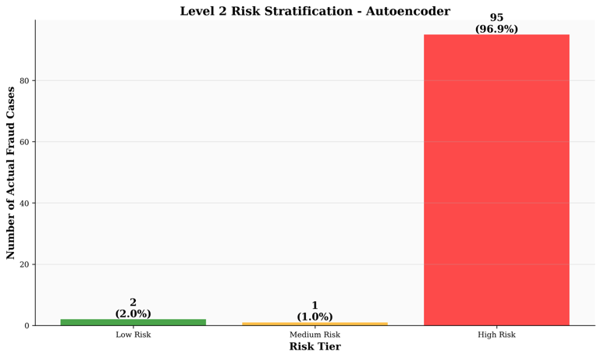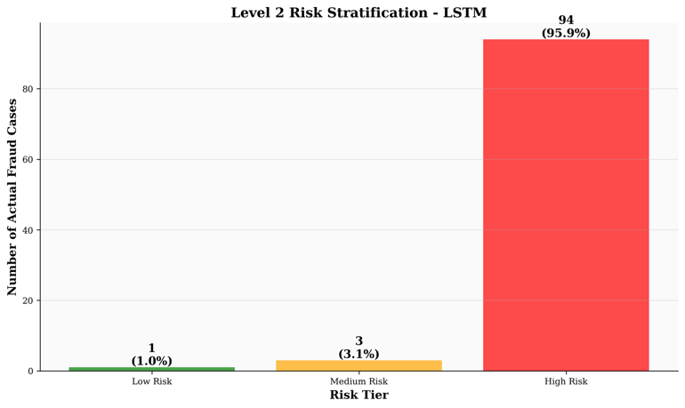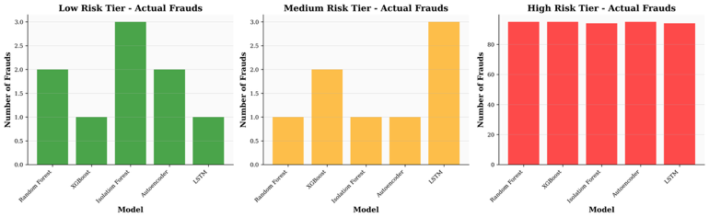
Fig. 4–9. Level 2 stratification results. Figs. 4–8: individual model fraud distributions. Fig. 9: all five models concentrated 94–97% of frauds in the High Risk tier.
V. DISCUSSION
A. Hyperparameter Sensitivity Analysis
Optimization reveals a clear sensitivity spectrum. Random Forest’s near-zero response (−0.08%) reflects ensemble averaging: 200 bootstrap-aggregated trees smooth out individual configuration changes. XGBoost’s +2.45% gain confirms stochastic regularization (row/column subsampling) is critical under extreme imbalance at moderate depth (6). Isolation Forest’s dominant +28.90% was driven entirely by contamination=0.00172 matching the true fraud rate even a 3× overestimate reduces AUPRC by over 10 percentage points. The Autoencoder’s null response suggests the reconstruction-error paradigm on PCA-whitened data is the limiting factor, not bottleneck dimensions. LSTM’s +1.40% reflects the capacity sensitivity typical of recurrent networks.
B. Model-Agnostic High Risk Fraud Concentration
The 94.9–96.9% High Risk capture consistency across architectures spanning an AUPRC range of 0.27–0.87 (a 3.2× spread in discriminative power) is the most practically significant Q3 result. This consistency arises because tercile thresholds are computed from the full test score distribution dominated by the 99.8% legitimate majority fraudulent transactions occupy the upper tail of any reasonable anomaly score distribution, creating a ceiling effect robust to model choice. The primary operational differentiator between models is therefore false-positive burden, not fraud capture: reviewing only the High Risk tier (33% of transactions) captures ≥95.9% of frauds at approximately one-third the review cost of scanning all transactions.
C. Operational Implications for Q4
The tiered framework provides a compelling efficiency argument: a system reviewing only the High Risk tier captures ≥95.9% of frauds while examining just one-third of all transactions, compared to 100% transaction review with an unranked binary classifier. Medium Risk cases (1–3 frauds per model) are the primary target for Q4 ensemble improvement through consensus voting. Low Risk (at most 3 fraud escapes across all models) can be processed with minimal overhead, freeing investigative resources for higher-priority tiers. This resource-proportional approach has direct implications for regulatory compliance and operational cost control in production fraud systems.
VI. CONCLUSION
This paper presented hyperparameter optimization and Level 2 risk stratification for five fraud detection architectures on the Kaggle Credit Card Fraud Detection benchmark. Grid search across 150 configurations achieved gains for XGBoost (+2.45%, AUPRC 0.8687), Isolation Forest (+28.90%, AUPRC 0.2693), and LSTM (+1.40%, AUPRC 0.8133), while demonstrating that ensemble methods with strong baselines (Random Forest) are largely configuration insensitive. The tercile-based Level 2 framework concentrated 94.9–96.9% of test frauds in the High Risk tier consistently across all five architectures supervised, unsupervised, tree-based, and neural establishing a robust, model-agnostic fraud prioritization mechanism.
Quarter 4 will pursue three directions: (1) tier-consensus ensemble voting across the five models to reduce Low and Medium tier fraud escapes; (2) cost-sensitive threshold optimization as an alternative to fixed tercile boundaries; and (3) SHAP-based model explainability to provide interpretable justifications for High Risk tier assignments a requirement for regulatory compliance in deployed fraud systems.
REFERENCES
[1] ULB Machine Learning Group, “Credit Card Fraud Detection Dataset,” Kaggle, 2016.
[2] L. Breiman, “Random forests,” Machine Learning, vol. 45, no. 1, pp. 5–32, 2001.
[3] T. Chen and C. Guestrin, “XGBoost: A scalable tree boosting system,” in Proc. ACM SIGKDD, 2016, pp. 785–794.
[4] A. Dal Pozzolo et al., “Learned lessons in credit card fraud detection,” Expert Syst. Appl., vol. 41, no. 10, pp. 4915–4928, 2014.
[5] F. T. Liu, K. M. Ting, and Z.-H. Zhou, “Isolation forest,” in Proc. IEEE ICDM, 2008, pp. 413–422.
[6] S. Hariri, M. C. Kind, and R. J. Brunner, “Extended Isolation Forest,” IEEE Trans. Knowl. Data Eng., vol. 33, no. 4, pp. 1479–1489, 2021.
[7] G. E. Hinton and R. R. Salakhutdinov, “Reducing the dimensionality of data with neural networks,” Science, vol. 313, pp. 504–507, 2006.
[8] T. Schlegl et al., “Unsupervised anomaly detection with generative adversarial networks,” in Proc. IPMI, 2017, pp. 146–157.
[9] S. Hochreiter and J. Schmidhuber, “Long short-term memory,” Neural Comput., vol. 9, no. 8, pp. 1735–1780, 1997.
[10] Y. Jurgovsky et al., “Sequence classification for credit-card fraud detection,” Expert Syst. Appl., vol. 100, pp. 234–245, 2018.
[11] T. Fawcett and F. Provost, “Adaptive fraud detection,” Data Min. Knowl. Discov., vol. 1, no. 3, pp. 291–316, 1997.
[12] C. Elkan, “The foundations of cost-sensitive learning,” in Proc. IJCAI, 2001, pp. 973–978.

